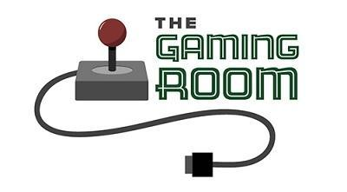

Draw it Or Lose It

CS 230 Project Software Design Template
Version 1.0

Table of Contents

CS 230 Project Software Design Template 1
Table of Contents 2
Document Revision History 2
Executive Summary 3
Requirements 3
Design Constraints 3
System Architecture View 3
Domain Model 3
Evaluation 4
Recommendations 5

Document Revision History

Version | Date | Author | Comments
1.0 | 01/23/2026 | Elijah Prosperie | Filling out template for project one.

Instructions
Fill in all bracketed information on page one (the cover page), in the Document Revision History table, and below each header. Under each header, remove the bracketed prompt and write your own paragraph response covering the indicated information.

Executive Summary

The Game Room company is looking to add on to its game of Draw it or Lose It and make it into a web-based application that can support multiple teams and competitive gameplay. Aiming for an expanded accessibility approach to reach users across numerous devices such as desktop and mobile phones browsers. Knowing this, we can plan to execute the web-application with the idea of keeping it scalable and secure.

To do this, I plan to use a solution involving a client-server, web-based architecture to allow players connection through the browser but maintain logic, storage, and user management in a centralized server. This allows easier maintenance, cross-platform compatibility, and helps with performance due to sharing a server for maintenance. Through this, we will be able to manage multiple, concurrent games, players, and teams while also ensuring each has their own id to be uniquely identified. This also ensures that as the web-application grows in users, the database is scalable and can grow with it.

Requirements

I’ll list out both the technical and business requirements.
Technical:

- Web-based client server-architecture
- Integrated, cross-platform web-application.
- Centralized server for game sessions, players, id’s, and teams
- Create a scalable system for future growth of users
- Create a centralized server to hold all data. Making the data manageable compared to having separate servers

Business:
- Keep the same, initial feeling users have on the Android-app.
- Games should all be unique and not override another session.
- Crossplay between desktop and web browsers is a must with both having the same degree of smooth gameplay.
- Numerous players and teams should be able to play at once.
- Web-application should be secure so that users can always play without worrying about losing sensitive information.

Design Constraints

Design Constraints:

- Client-server environment
  - The plan to holster all game logic and data on a centralized server makes security easier, however it also means a detailed network communication and careful design choice. More difficult than allowing data to be managed by device.
- Scalability
  - The app already is an established game. Making a web-application version means building onto that foundation but also building towards the expectation of an influx of players. Ensuring the database is scalable makes it easier to accept new players as well as returning.
- Data Integrity
  - Every user, game, and team must all be unique as to not override the other. This means that each needs their own ID. However, if that user is a mobile app player and playing on a web-browser. They need to be able to cross-over, but also not be allowed to play on two different devices at once.
- Cost
  - One of the most clear constraints is one that affects any application; cost. Both the cost of creation, as well as the cost of constant maintenance such as bug fixing, database management, and future features. Depending on the budget the company wishes to spend, features could directly be impacted as some might be cut due to the amount allocated to the project.
- Security
  - Maintaining security is of utmost importance. Ensuring that user information is not at risk of attacks is necessary when having a web-based application. As well as protecting the database itself which would hold all users information.

System Architecture View

Please note: There is nothing required here for these projects, but this section serves as a reminder that describing the system and subsystem architecture present in the application, including physical components or tiers, may be required for other projects. A logical topology of the communication and storage aspects is also necessary to understand the overall architecture and should be provided.

Domain Model

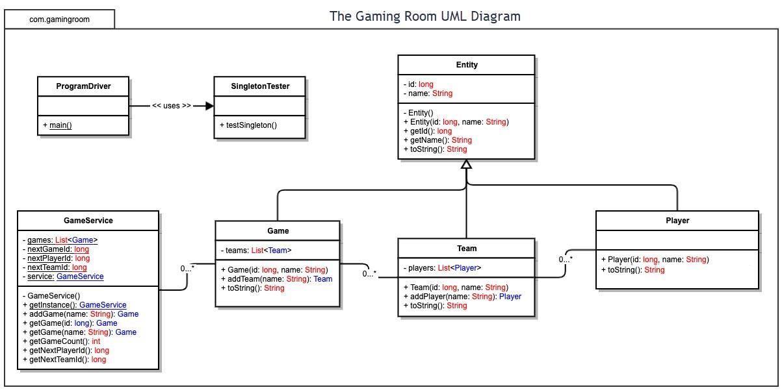

Entity Class:
- This is the base class.
- Here we have two private variables of id and name.
- Multiple methods are passed public to be called in other files that will use them.
- Game, Team, and Player are all extended from Entity.
Game Class:
- This class represents a singular game session.
- Since many teams can be in one game, it has a one-to-many relationship.
Team Class:
- This class represents a team or group within a game.
- One team can have multiple players. Meaning this is also a one-to-many relationship.
Player Class:
- This class represents individual players.
- Each player has their own, unique id.
- One player belongs to a team.
GameService Class:
- This class operates as the logic of tracking all games and unique ids for all.
- It uses a Singleton design pattern so that one instance can exist when the program is executed.
ProgramDriver Class:
- ProgramDriver is our main class.
- This allows the entire application to run and test the project.
SingletonTester Class:
- This file tests the Singleton design in our GameService class to make sure it is working properly.

Evaluation

Using your experience to evaluate the characteristics, advantages, and weaknesses of each operating platform (Linux, Mac, and Windows) as well as mobile devices, consider the requirements outlined below and articulate your findings for each. As you complete the table, keep in mind your client’s requirements and look at the situation holistically, as it all has to work together.

In each cell, remove the bracketed prompt and write your own paragraph response covering the indicated information.

Development Requirements | Mac | Linux | Windows | Mobile Devices
Server Side | macOS offers a Unix foundation that comes with strong security. However, its high hardware cost and scalability options limit it compared to others. | Linux stands as the most widely used platform for web-based applications due to its stability, security, and performance. It currently sits as the best all around for server side. | Windows has ease of integration with Microsoft technologies, strong enterprise support, and security. However, licensing costs can be high. | At the end, Mobiles Devices lack processing power and reliability for server side operations. While accessible, they are not recommended.
Client Side | Mac offers a multitude of browsers such as Chrome, Safari, etc. And with no specific version required to run the application, the primary consideration is browser compatibility. | Similar to Mac, Linux can also access our game through multiple web browsers. The major difference would be the smaller consumer market compared to Windows and Mac or even Mobile. | On the opposite of Linux, Windows sits as a rival to Mobile in terms of consumer market. Holding the largest desktop market by far. This means that it should be a key client platform and since the game is run in web-based. The cost overall should be small. | Mobile is a critical client platform. With a multitude of things to account for such as multitude of lengths for screens, touch input, and different brand hardware performance. It would be more costing, if designed for web-based across all mobile brands. It would still be better than designing for iOS/Android independent.
Development Tools | Mac has access to a plethora of IDE’s such as VS Studio Code, Eclipse, IntelliJ and more for code development. Plenty of languages like JavaScript and Python can be used for a front end. | Similar to Mac, Linux has access to tools like VS Code and IntelliJ as IDE’s. Linux is currently used commonly for server-end development with things such as Apache and containerization tools like Docker. | Windows you get the same access to all that Mac and Linux do. IDE’s, Git, and cloud tools all make developing both front and back-end server code simple on Windows. | Mobile development focuses on ensuring the niche of touch interface and screen control. Frameworks like React Native and Bootstrap are made specifically for mobile editing.

Recommendations

Analyze the characteristics of and techniques specific to various systems architectures and make a recommendation to The Gaming Room. Specifically, address the following:

- Operating Platform: For our operating platform, I believe Windows would be the optimal choice. Not only can you integrate its design to fit other OS’s, it is the most widely used desktop OS.

- Operating Systems Architectures: While Windows is the optimal choice for operating platform, I believe Linux works best for the systems architecture due to its common use in server-side database use. With our code being done in Java, it makes it easy to build a scalable app to be used in the client.

- Storage Management: I personally believe PostgreSQL would be the best storage database. It’s relational, meaning that it builds off the relations of the tables. So teams, game sessions, players, and user information would all be structured in storage. It also has the ability for back ups in event of attack or error, data integrity, and ability to be scaled.

- Memory Management: Windows can use a Virtual Memory system to run our application using our system's RAM(short-term memory). The Java Virtual Machine would be perfect because it has built in ways to automatically garbage collect unused memory.

- Distributed Systems and Networks: Using standard web protocols such as HTTP/HTTPS, we can have the application work as a distributed application. Ensuring our network infrastructure has minimal latency/downtime and uses redundancies for high traffic ensures reliability for users.

- Security: As mentioned above, standard web protocols are one form of security. However the use of authentication methods and server-side validation of inputs all play a part in ensuring data is secure and protected.

